**Sir Syed University**

**of Engineering & Technology**



WEB TECHNOLOGY

LAB PROJECT REPORT

MUHAMMAD MUBASHIR 2020F-BIT-016

SHAREYAR FAROOQUI 2020F-BIT-025

TALHA IMRAN 2020F-BIT-027

HASSAN AHMED 2020F-BIT-039

ABDUL HANNAN 2020F-BIT-045

SUBMITTED TO: MISS SOBIYA

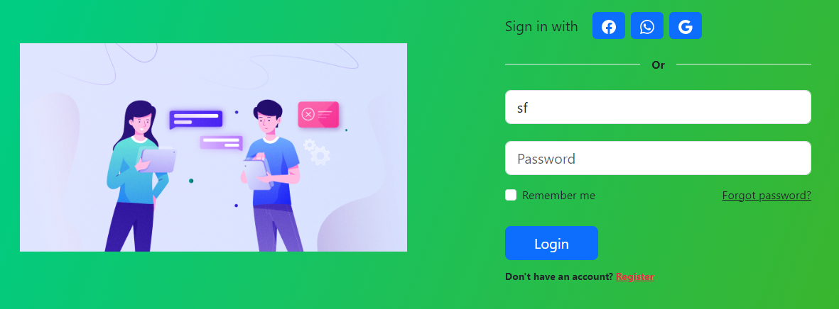

Our first page will be like this as it would require from user that he/she should enter login into their account.

If there is new user then he/she should register themselves in order to enter website.

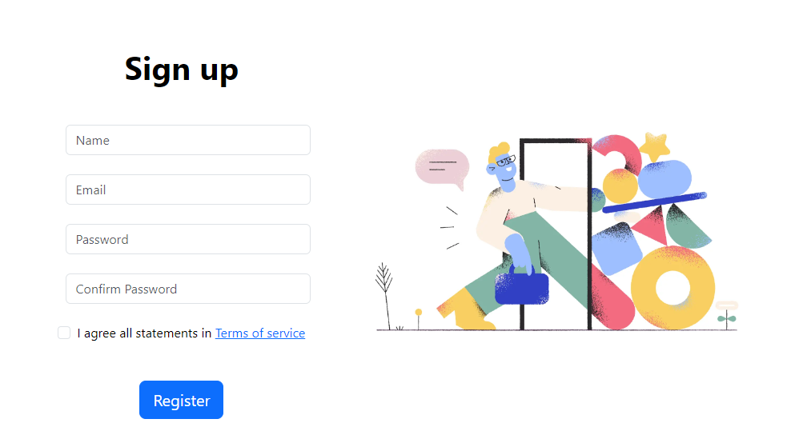

Fill up basic details and new user will be created.

Once logged in the user will be redirected to their home page.

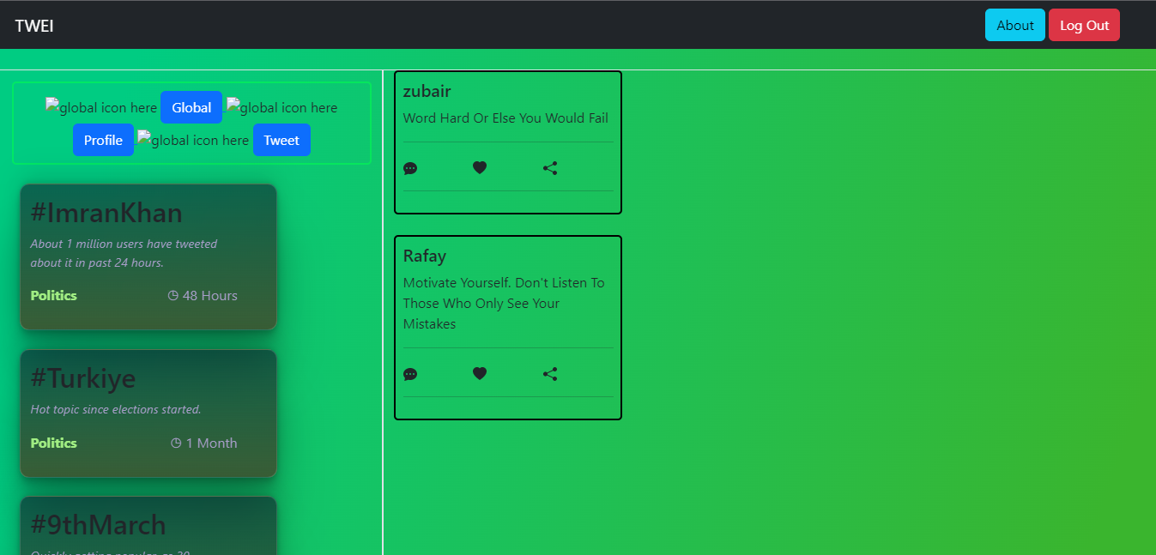

Which will look like this.

There are 3 aspects of home page.

1. Tweets: they can be found on right side of screen. It will display all tweets of users on TWEI social networks.
2. Trending List: highlighting all hot topics that people are talking about right now in the world.
3. Bar: It will help user to redirect himself to direct areas of website like visiting their profile and etc.

Once user click on tweet button, a dialog will be displayed to help user create a new tweet. That dialog will look like this:

